Sample paper 2
Subject : Multimedia And Web Technology Class: XII (Set -B)
Time allowed: 3 hours Maximum Marks : 70
Note :
- Please check that this question paper contains 7 questions..
- Answer the questions after carefully reading the text.
- Please write down the serial number of the question before attempting it .
___________________________________________________________________
Q1.
- What are the disadvantages of file cabinet system over computerised system? 1
- How degree and cardinality is related to a relation? 1
- Name the following 1
- A data type used for logical value(true/false) in the database.
- A key that does not allow Null values and must always have a unique value.
- Study the following data and answer the questions given below : 3
Table : Pancard.mdb
Permanent Account Number | Name | Father Name | Date Of Birth
Atbpe3452g | Er. Ramesh Gupta | Sh. Keshav Gupta | 22-9-1989
Sdfg324erg | Dr. Mahipal Rawat | Sh. Magesh Rawat | 9-10-1965
Dfghj234ty | Tr. Leelawati George | Sh. S.K.George | 8-9-1945
Table: Moneytransaction .mdb
Permanent account number | Debit | Credit | balance
Sdfg324erg | 45000 |  | 145000
Atbpe3452g |  | 676543 | 32678
Sdfg324erg |  | 65432 | 79568
i. Suggest the data types that should be used for each of the fields in the pancard table .
ii. Write the relationship between “pancard” and “moneytransaction” table.
iii. Name the field that can act as a primary key in “pancard” table and name the foreign key of “moneytransaction” table.
e) Write a short note on how multimedia is being used in healthcare. 1
f) Give two differences between AVI and MPEG file format. 1
g) What is the use of <EMBED> tag? Write any three attributes of <EMBED> tag. 1
h) Name the extension of the file created when a Flash movie is published using a Windows projector. 1
Q2. Questions given below are based on Macromedia Flash:
- How the arrow tool is different from subselect tool? 1
- Differentiate between .FLA and .SWF files. 2

Q7. Answer the following questions based on Communication and network concepts:
- Name any two guided and two unguided media. 1
- Name the transmission media that can be used in 1
    - Sparsely populated areas
    - Unidirectional
- What are the role of TCP and IP in TCP/IP protocol? 1
- Define point to point and multipoint video conferencing. 1
- Write short notes on i) FLOSS ii) TOMCAT 2
- Lakhani Organisation has set up its new center at palwal for its office and web based activities. It has 4 blocks of buildings as shown below: 4
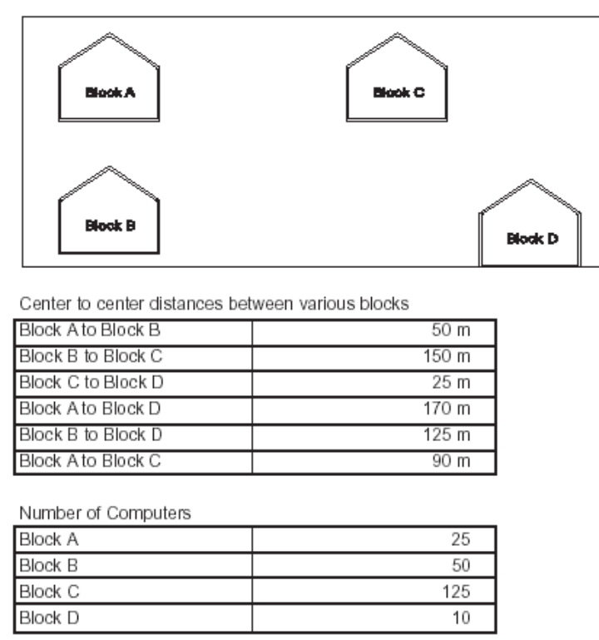
(i) Suggest a cable layout of connections between the blocks also name the topology .
(ii) Suggest the most suitable place (i.e. block) to house the server of this organization with a suitable reason.
(iii) Suggest the placement of the following devices with justification
• Repeater • Hub/Switch
(iv) If the organization needs to link up to a branch office which is in a neighboring city, (around 60 km distant) suggest the best type of cabling connection, from the building hosting the server, provided price is not a factor.

Subject_code | Admno
067 | 5079
067 | 9873
301 | 6875
301 | 5079
030 | 5444

5. Answer the following questions based on ASP:
- Differentiate between optimistic and pessimistic locking of a recordset.
1
- Describe the following 1
    - Flush Method
    - Execute Method
- How many methods do the following components have? Name them. 1
    - Counter
    - Content Rotator
- Underline the errors in the following code and write the corrected script. 2
<% option explicit
dim arr(8),max
arr=array(25,14,20,45,25,4,1,31)
max=upbound(arr)
for i=max to 1 go -2
arr(i)*10= arr(i)
document.write (arr(i) & “<br>” )
loop %>

- Give the output for the following code segment: 2
<%fun carbonfootprint(c,b,d)
dim cfp
if d <40 then
cfp=c*600+b*200
elseif d<100 and d>40 then
cfp=c*1000+b*500
else
msgbox(“do not use your own vehicle ”)
end if
carbonfootprint=cfp
end function%>

rem main program

<% dim car , bike , distance
car=3
bike=2
distance=47
response.write(carbonfootprint(car,bike,distance))
%>
- Write an ASP program to read a text file named “mount.txt” and display the contents of the file on the screen after converting all “i” to upper case letters. 3

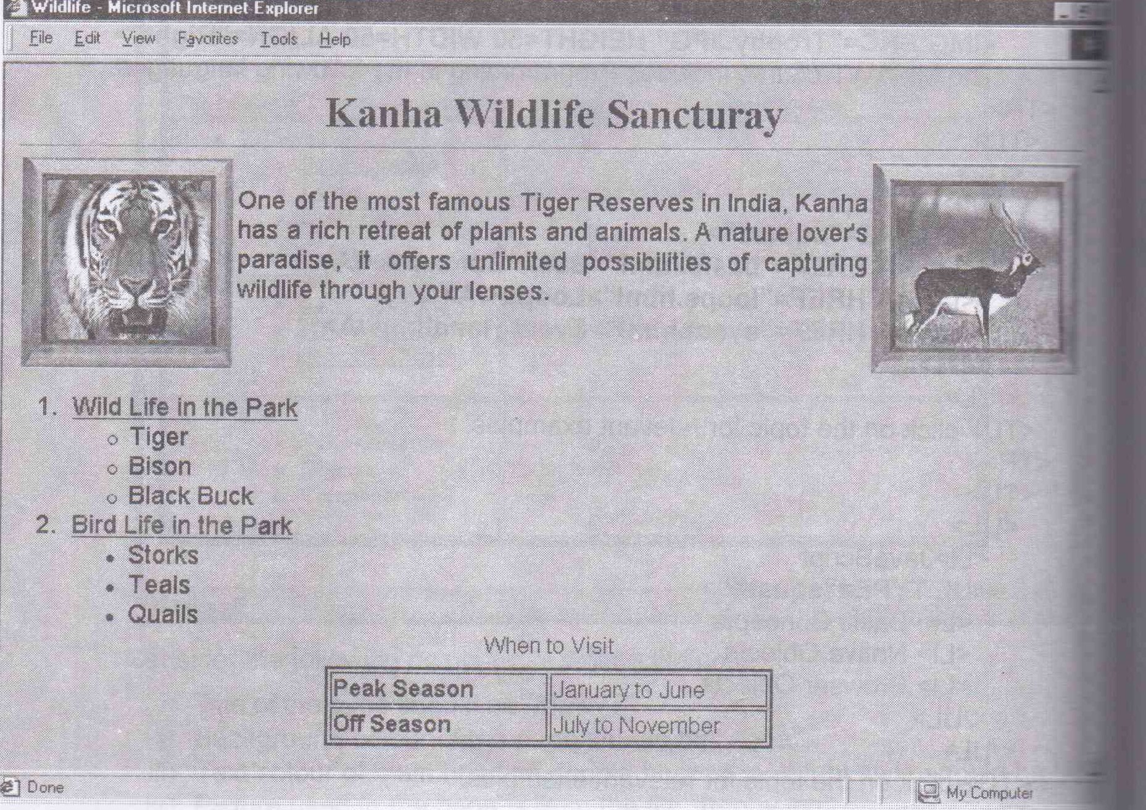

Q 4. Answer the following questions based on ASP:
- Explain with examples two ways in which server – side scripts can be added to an HTMLdocument. 1
- Name any three equivalent tools of ASP. 1
- What is the significance of the option explicit statement? 1
- Define keyword “ReDim Preserve”. 2
- What is a cookie? What kind of information can be stored in cookies? 2
- Find output 3
- Response.write(strreverse (mid(“card game”,sqr(16),day(date())/7)))
- Response.write(left(“special character”,month(date()) mod 6))
- Response.write(lcase (mid(“discription”,8,instr(“performed”,”rm”))))

- Differentiate between Regular frame and Key frames. 1
- Explain the usage of sound panel. 1
- What is the use of publish preview option? What are the default preview settings? 1
- Observe the figure given bellow and do as directed : 4
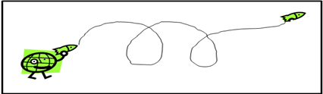
- The image on the left side shows the position of the image for frame 1.
- The image on the right side shows the position of the image for frame 50.
The dotted line shows the path of motion of image.
Write procedure and property setting for animating the above scenario.
Q3 . Question given below are based on HTML:
- Name the tag and attributes 2
    - To sets the top/bottom margin of the web page.
    - Specifies the vertical placement of the text in the cells.
- Write a note on the different types of lists available in HTML. 1
- Write the HTML code to generate a Web Page in the format given below : 7
Consider the following while writing the HTML code :

1. Title of the page should be “Wildlife”
2. Background colour of the page should be “Silver”.
3. Font used on the page is “Arial”.
4. Pictures used in the page are the ie,, Tiger.jpg” and “blackbuck.jpg”
5. Use the concept of nested lists for creating the list given in the web page 1 specified bullets.
6. Table should have a border of width 2 and the caption “When to Visit”.
7. Pages linked to:
• Wild Life in the Park as “wild.html”
• Bird life in the Park as “bird.html”

Q6. Answer the following questions based on VBScript:
- Differentiate between subroutines and functions. 2
- Write the equivalent script for the following code using For…..next without effecting the output: 2
<SCRIPT LANGUAGE=”VBScript”>
DIM p,q
p=3
q=5
DO
p=p*q
q=q+2
loop while q<=10
document.write(p)
</SCRIPT>
c) Give the output of the following code segment: 2
<SCRIPT LANGUAGE=”VBScript”>
Dim cities()
Dim visit
Visit=2
Redim cities(visit)
cities(0)=”Faridabad”
cities(1)=”Delhi”
cities(2)=”palwal”
redim cities(visit+2)
cities(3)=”Dehradun”
cities(4)=”Mussoories”
document.write(cities(0))
document.write(cities(1))
document.write(cities(2))
document.write(cities(3))
document.write(cities(4))
</SCRIPT)
- Write the HTML code for creating the form given below and also write the embedded VBScript code for the click event of the submit button. 4


